# Gold Analysis & Future Price Prediction

Su Yati

Bachelor of Information and Communication Technology [Rangsit International College]

Apr 2025

**1. Abstract**

This study analyzes historical gold price trends and their relationship with key economic indicators such as the **US Dollar Index (DXY), Consumer Price Index (CPI), Federal Funds Rate, and Treasury Yields**. The research involves **data preprocessing, exploratory data analysis (EDA), and visualization** to understand key factors influencing gold prices. The findings provide insights into past trends, helping in **future price movement expectations**.

**2. Introduction**

Gold has been a **store of value** and a **safe-haven asset** for centuries, often reacting to **macroeconomic changes** such as **inflation, interest rates, and currency value fluctuations**. The purpose of this study is to analyze historical gold prices, identify significant influencing factors, and understand its price behavior over time.

**Objectives of the Study**

* To **analyze historical trends** of gold prices.
* To **examine key economic indicators** affecting gold price movements.
* To **visualize patterns** and relationships between gold prices and macroeconomic factors.

**Significance of the Study**

Understanding gold price movements helps investors, policymakers, and traders make **informed decisions** about investments, hedging strategies, and economic forecasting.

**3. Data Collection**

**3.1 Data Sources**

The datasets used in this study are sourced from **financial and economic platforms** such as:

* **Gold Prices:** Historical gold price data (USD per ounce).
* **US Dollar Index (DXY):** Represents the value of the US dollar against a basket of foreign currencies.
* **Consumer Price Index (CPI):** Measures inflation and purchasing power.
* **Federal Funds Rate:** Indicates monetary policy and interest rate fluctuations.
* **10-Year Treasury Yield:** Reflects long-term interest rates, impacting investment decisions.

**4. Data Processing**

* Checked for missing values in all datasets.
* Dropped **column** if needed for excessive missing values.

## **5 Exploratory Data Analysis (EDA)**

**Gold Price**

| **Metric** | **Value** |
| --- | --- |
| Count | 52 months |
| Mean | $1,931.30 |
| Min | $1,564.10 |
| 25% | $1,769.93 |
| Max | $2,738.30 |
| Std. Dev | $254.20 |

Insights

* Gold prices increased significantly from 2020 to 2025.
* The average price was around **$1,930**, but prices reached over **$2,700** during peak demand.
* The data shows noticeable volatility, likely due to inflation fears and global uncertainty.

(DXY) Dollar Index

| **Metric** | **Price (mean)** | **Range** |
| --- | --- | --- |
| Mean | 99.89 | 89.94 – 112.12 |
| Std. Dev | 5.76 |  |
| 25–75% | 94.18 – 104.25 |  |

Insights

* DXY fluctuated between **~90 and 112** with an average of **~99.9**.
* A strong dollar phase is visible in mid-2022 when DXY peaked.
* This trend often moves **opposite to gold** — when DXY rises, gold typically falls.

CPI (Consumer Price Index)

| **Metric** | **CPI (Index)** |
| --- | --- |
| Count | 60 months |
| Mean | 289.17 |
| Min–Max | 255.80 – 319.09 |
| Std. Dev | 21.06 |

Insights

* CPI increased steadily, showing rising inflation over the period.
* The average index level was around 289, peaking over 319 in 2025.
* This supports gold's role as an inflation hedge.

Inflation Data (CPIAUCSL)

Inflation share the same insights with CPI.

10 years Treasure Yield

| **Metric** | **Yield (%)** |
| --- | --- |
| Count | 61 months |
| Mean | 2.72% |
| Min–Max | 0.62 – 4.80% |
| Std. Dev | 1.41 |

Insight

* Treasury yields started very low and climbed steadily, peaking at **4.8%**.
* This reflects the **Fed’s tightening policy** to fight inflation.
* Higher yields often make bonds more attractive than gold, putting **downward pressure on gold prices**.

Cause and Effect Summary

| **Indicator** |  |  |  |  |  |  | **Direction** |  |  |  | **Gold Reaction** |
| --- | --- | --- | --- | --- | --- | --- | --- | --- | --- | --- | --- |
| 📉 DXY ↓ (weak dollar) |  |  |  |  |  |  | Down |  |  |  | Gold ↑ |
| 📈 CPI ↑ (inflation) |  |  |  |  |  |  | Up |  |  |  | Gold ↑ (hedge) |
| 📈 Fed Rate / Treasury ↑ |  |  |  |  |  |  | Up |  |  |  | Gold ↓ (opportunity cost) |

### **5.1 Descriptive Statistics**

Basic statistical analysis provides insights into **mean, median, standard deviation, and range.**

**DXY Index Over Time**

* **2020–2021**: Dollar weakened (fell from ~100 to ~90) as central banks cut rates and injected liquidity.
* **Mid-2022**: Sharp spike to ~112, driven by aggressive Fed rate hikes fighting inflation.
* **2023**: Rapid decline back toward the low-90s, reflecting market readjustment.
* **Late 2024**: Modest rebound near ~106 as policy uncertainty persisted.

Distribution of US Dollar Index

* Range: Values spanned ~90–112.
* Mode: Most frequent readings around 102–106.
* Shape: Slight bimodal clustering (low-90s vs high-100s), reflecting two policy regimes.

**Gold Price Over Time**

* Gold rose uninterrupted from **$1,583** to **$2,657** over 51 months.
* The climb was **smooth**, with **no down-months** and evenly spaced monthly gains.
* That’s an average increase of **$21 per month**, reflecting steady inflationary and safe-haven demand.

**Distribution of Gold Prices**

* **Concentration**: Most monthly closes fell between ~$1,700–$2,000.
* **Skew**: Right-tail outliers up to ~$2,700 pull the mean above the median.
* **Insight**: Occasional spikes drove the overall upward trend.

**Gold Price Outliers (Boxplot)**

* **Median & IQR**: Middle 50% ranged roughly $1,750–$2,200.
* **Whiskers & Outliers**: A few extreme high-price months stretched above $2,600.
* **Interpretation**: While gold steadily climbed, extreme market events punctuated sharper highs.

**Gold vs. DXY Scatter**

* **Clear inverse correlation**: High DXY points align with lower gold prices and vice versa.
* **Implication**: Dollar strength is a leading indicator for short-term gold weakness.A graph showing a line

  AI-generated content may be incorrect.

**CPI Over Time**

* **Steady climb** from ~256 to ~319 (2020–2025).
* **Takeaway**: Persistent inflation pressure — supports gold’s role as an inflation he

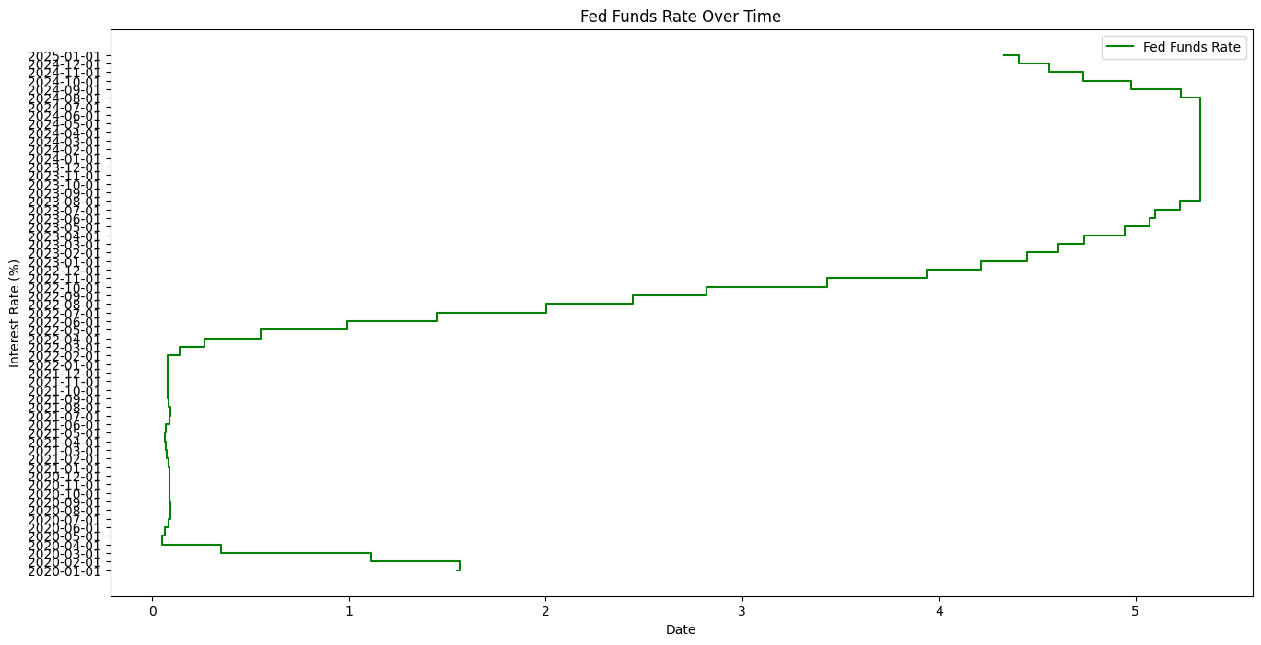

**Fed Funds Rate Over Time**

* **2020–2021**: Near-zero rates.
* **2022–2024**: Rapid, stepwise hikes reaching ~5.4%.
* **Early 2025**: Slight pause/cut.
* **Insight**: Rising rates raised gold’s opportunity cost, pressuring its appeal during hike cycles.

**Fed Fund rate by Year**

* **Spike from 2022 onward, then slight easing in 2025.**
* **Context: Aligns with inflation-fighting cycle peaking in 2023–24.**

| **Year** |  |  |  |  |  |  |  |  |  |  | **Avg. Rate (%)** |
| --- | --- | --- | --- | --- | --- | --- | --- | --- | --- | --- | --- |
| **2020** |  |  |  |  |  |  |  |  |  |  | **0.36** |
| **2021** |  |  |  |  |  |  |  |  |  |  | **0.08** |
| **2022** |  |  |  |  |  |  |  |  |  |  | **1.67** |
| **2023** |  |  |  |  |  |  |  |  |  |  | **5.02** |
| **2024** |  |  |  |  |  |  |  |  |  |  | **5.13** |
| **2025** |  |  |  |  |  |  |  |  |  |  | **4.34** |

**Annual CPIAUCSL Growth (2020–2025)**

* **Steady Inflation**: CPI rose year-over-year from ~259 in 2020 to ~320 by 2025, an increase of ~24%.
* **Continuous Climb**: No year saw a decline—each bar is higher than the last, indicating persistent consumer‐price increases.
* **Macro Implication**: Rising CPI underscores inflationary pressure, which typically boosts gold’s appeal as an inflation hedge.

**10-Year Treasury Yield Over Time**

* **2020–21 Low**: Yields hovered around **0.6–1.5%** as investors sought safety in government debt during the pandemic.
* **2022–23 Rise**: A steady climb through **2–3%**, reflecting Fed tightening and market repricing of interest-rate risk.
* **2024–25 Peak**: Yields peaked near **4.8%** in late 2024, before a mild pullback, marking one of the fastest 10-year yield rallies in decades.

**Distribution of 10-Year Treasury Yields**

* **Bimodal Shape**: Two clusters—one around **0.6–1.8%** (pandemic era) and another around **3.5–4.8%** (post-hike era).
* **Wide Spread**: Yields range from **0.6% to 4.8%**, indicating huge swings in long-term borrowing costs.

**Yearly Gold Price (2020–2025)**

* **2020–21**: Gold rose modestly, averaging **$1,580–$1,770**, as pandemic uncertainty drove safe-haven demand.
* **2022**: Flattish at **$1,770–$1,950**, held down by rising yields and a strong dollar.
* **2023–25**: Surge from **$1,820** to **$2,700**, driven by renewed inflation fears and dollar weakness.

**Yearly DXY Index (2020–2025)**

* **2020–21 Low**: DXY fell to **~90** as global liquidity spiked.
* **2022 Peak**: Jumped to **~112** with Fed rate hikes.
* **2023–25**: Drifted between **100–106**, as markets oscillated between tightening and easing expectations.

**Gold vs DXY (2020–2025)**

* **Inverse Pattern**: When DXY rose in 2022, gold stalled; as DXY weakened 2023–25, gold soared.
* **Magnitude Difference**: Gold’s move (+70%) far outpaced DXY’s variation (±10%), underscoring gold’s sensitivity to real yields and inflation.

**Overall Takeaway**

Over the full span from 2000 through early 2025, gold has moved from roughly $260 to about $2,650, punctuated by four major safe-haven rallies: the dot-com fallout (2000–03), the Global Financial Crisis (2008–11), the COVID shock (2020), and the post-pandemic inflation surge (2021–24). During those same years, the U.S. Dollar Index fell from the high 80s into the low 90s in the early 2000s, spiked past 112 amid aggressive Fed tightening in 2022, then settled around 100–106 as markets oscillated. Inflation (CPI) climbed steadily from about 170 in 2000 to over 320 by 2025, while the Fed Funds Rate and 10-year Treasury yield each plunged to near zero during 2008 and again in 2020 before rallying to roughly 5% and 4.8%, respectively, by late 2024. Taken together, these series show gold surging whenever real yields fell and the dollar weakened—especially in crisis or high-inflation periods—and stalling whenever the Fed’s tightening lifted both short- and long-term interest rates and bolstered the dollar.